CIS2058-N Assessment Test Plan
Apex
Carl Baines
Name: Carl Baines
Module: Web Apps & Services
Date: 14/12/2025
Tutor Name: Tyrone Davison

Contents
Test Plan 1

Test Plan

TEST ID | Requirement | test type | test description | input | expected output | result | notes
1 | Web Services (Apex.Catering) to create, edit, delete and list food items - see the ERD above for details; | VALID | Create a Food Item | POST /api/PostFoodItem  Body: {"itemName":"Chicken Curry","description":"Mild curry","unitPrice":6.50} | 201/200; response includes foodItemId; item persists | 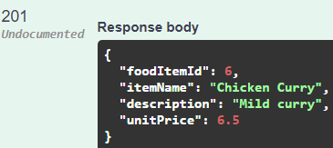 | N/A
2 | Web Services (Apex.Catering) to create, edit, delete and list food items - see the ERD above for details; | VALID | List Food Items | GET /api/FoodItems | 200; returns list including new item | 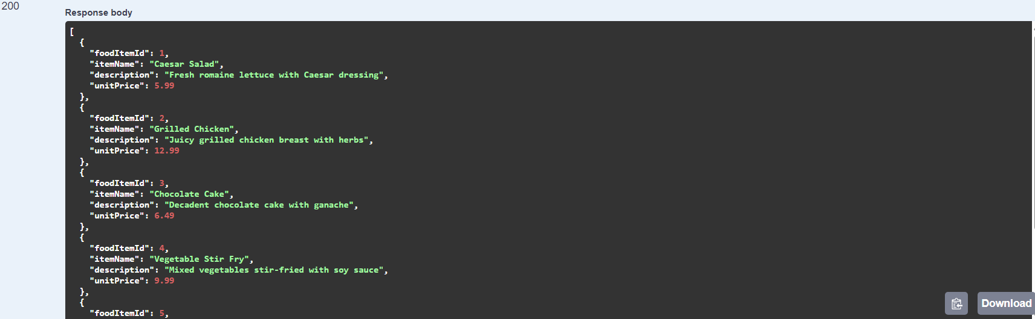 | N/A
3 | Web Services (Apex.Catering) to create, edit, delete and list food items - see the ERD above for details; | VALID | Edit a Food Item | PUT /api/PutFoodItem/{foodItemId}  Body: {"foodItemId":<id>,"itemName":"Chicken Curry","description":"Spicy curry","unitPrice":7.00} | 204/200; subsequent GET shows updated values | 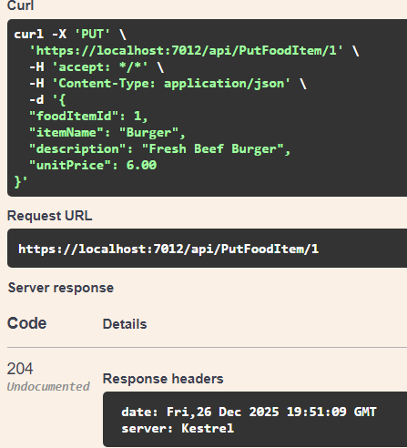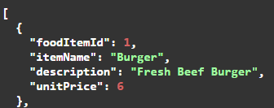 | N/A
4 | Web Services (Apex.Catering) to create, edit, delete and list food items - see the ERD above for details; | VALID | Delete a Food Item | DELETE /api/DeleteFoodItem/{foodItemId} | 204/200; subsequent GET by id returns 404 | 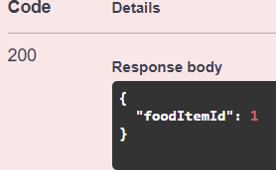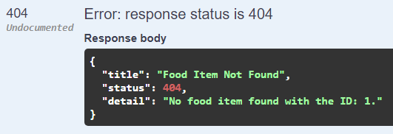 | N/A
5 | Web Services (Apex.Catering) to create, edit, delete and list the details of food Menus - see the ERD above for details; | VALID | Create a Menu | POST /api/PostMenu  Body: {"menuName":"Standard Buffet"} | 201/200; response includes menuId; menu persists | 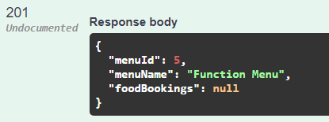 | N/A
6 | Web Services (Apex.Catering) to create, edit, delete and list the details of food Menus - see the ERD above for details; | VALID | List Menus | GET /api/GetMenu | 200; returns list of menus | 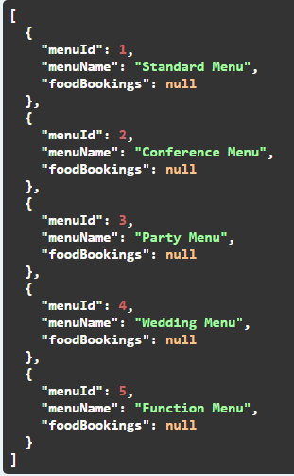 | N/A
7 | Web Services (Apex.Catering) to create, edit, delete and list the details of food Menus - see the ERD above for details; | VALID | Edit a Menu | PUT /api/PutMenu/{menuId}  Body: {"menuId":<id>,"menuName":"Premium Buffet"} | 204/200; subsequent GET shows updated values | 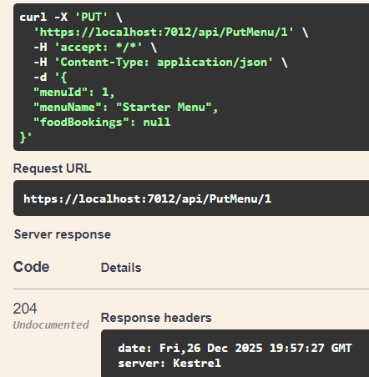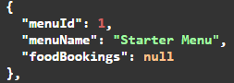 | N/A
8 | Web Services (Apex.Catering) to create, edit, delete and list the details of food Menus - see the ERD above for details; | VALID | Delete a Menu | DELETE /api/DeleteMenu/{menuId} | 204/200; subsequent GET by id returns 404 | 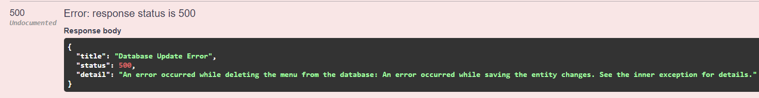 | Unintended behaviour – a database update error occurred.
9 | Web Services (Apex.Catering) to add and remove a food item from a menu - see the ERD above for details; | VALID | Add Food Item to Menu | POST /api/PostMenuFoodItem  Body: {"menuId":<menuId>,"foodItemId":<foodItemId>} | 201/200; association created | 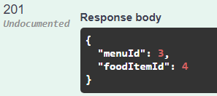 | N/A
10 | Web Services (Apex.Catering) to add and remove a food item from a menu - see the ERD above for details; | VALID | Remove Food Item from Menu | DELETE /api/DeleteMenuFoodItem/{menuId}/{foodItemId} | 204/200; association removed | 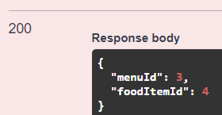 | N/A
11 | Web Services (Apex.Catering) to book, edit and cancel Food for an Event - see the ERD above for details. The service should return the FoodBookingId as confirmation of the booking; | VALID | Book Food for an Event and confirm FoodBookingId returned | POST /api/FoodBookings  Body: {"eventId":<existingEventId>,"menuId":<menuId>,"numberOfGuests":50,"clientReferenceId":12345} | 201; response includes foodBookingId confirmation | 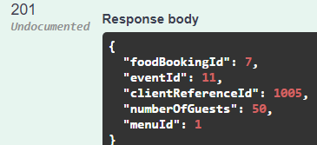 | N/A
12 | Web Services (Apex.Catering) to book, edit and cancel Food for an Event - see the ERD above for details. The service should return the FoodBookingId as confirmation of the booking; | VALID | Edit Food Booking for an Event | PUT /api/FoodBookings/{foodBookingId}  Body: {"foodBookingId":<id>,"eventId":<existingEventId>,"menuId":<menuId2>,"numberOfGuests":60,"clientReferenceId":12345} | 204/200; subsequent GET shows updated values | 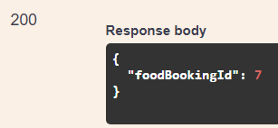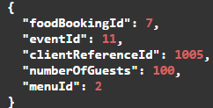 | N/A
13 | Web Services (Apex.Catering) to book, edit and cancel Food for an Event - see the ERD above for details. The service should return the FoodBookingId as confirmation of the booking; | VALID | Cancel Food Booking for an Event | DELETE /api/FoodBookings/{foodBookingId} | 204/200; subsequent GET returns 404 (or shows cancelled if implemented) | 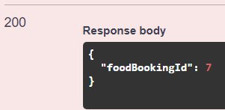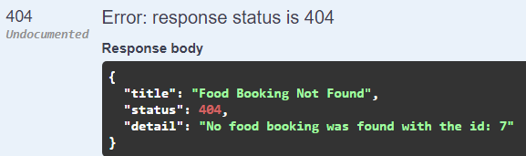 | N/A
14 | Create a new Event, specifying as a minimum its title, date and EventType; | VALID | Create a new Event | UI: Events > Create  Title: Winter Gala  Date: 2026-01-15  EventType: Conference  Venue: select any available | Event created; appears in Events list | 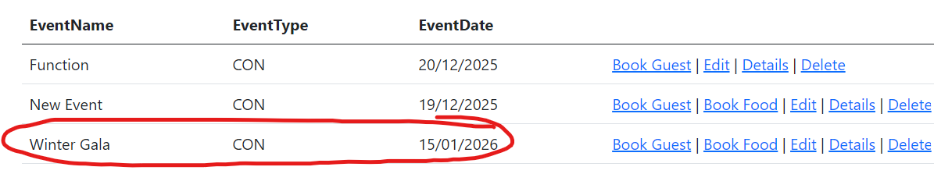  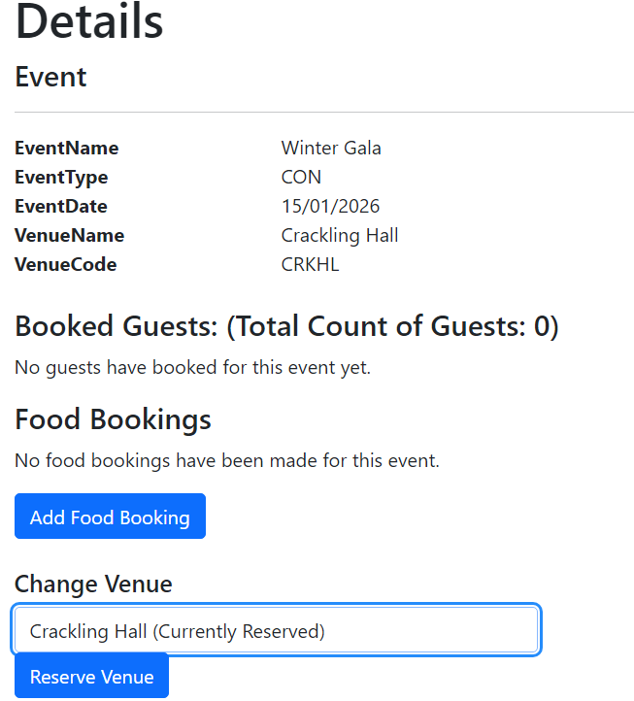 | N/A
15 | Create a new Event, specifying as a minimum its title, date and EventType; | INVALID | Create Event with missing required field(s) | UI: Events > Create  Leave Title or Date or EventType blank | Validation shown; event not created | 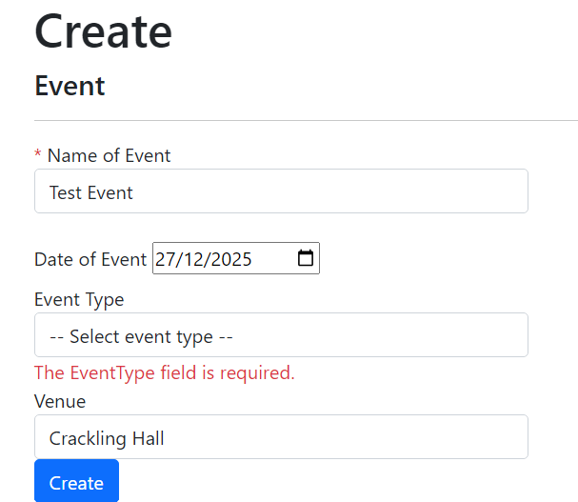 | N/A
16 | Create, list and edit Guests; | VALID | Create Guest | UI: Guests > Create  First: Ava  Last: Singh  Email: ava@example.com | Guest created; appears in Guests list | 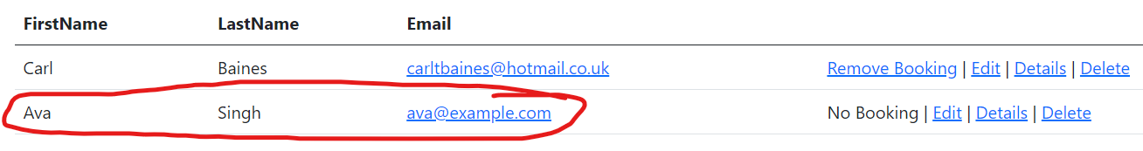 | N/A
17 | Create, list and edit Guests; | VALID | List Guests | UI: Guests > Index | Guests list displayed including new guest | 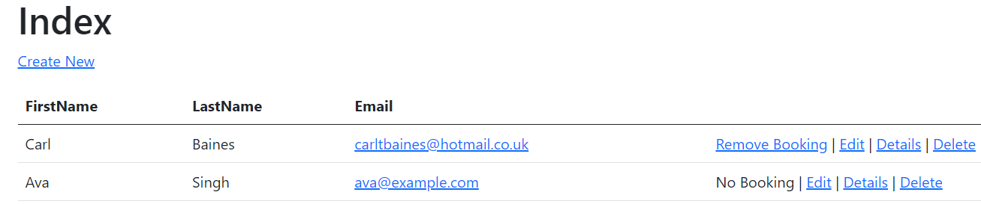 | N/A
18 | Create, list and edit Guests; | VALID | Edit Guest | UI: Guests > Edit  Change LastName to Patel | Guest updated; list/details reflect change | 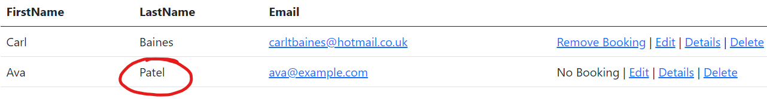 | N/A
19 | Book (add) a Guest onto an Event; | VALID | Book a Guest onto an Event | UI: Events > BookGuest (from Event)  Select Guest <guestId> | Booking created; guest appears under Event guest list | 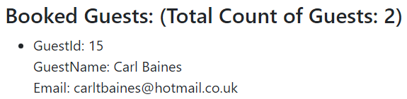 | N/A
20 | Book (add) a Guest onto an Event; | INVALID | Prevent duplicate guest booking (negative) | Attempt to book same Guest to same Event twice | Duplicate prevented; user shown error or no duplicate created | 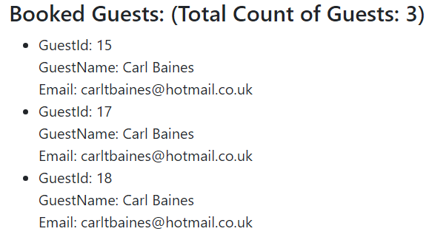  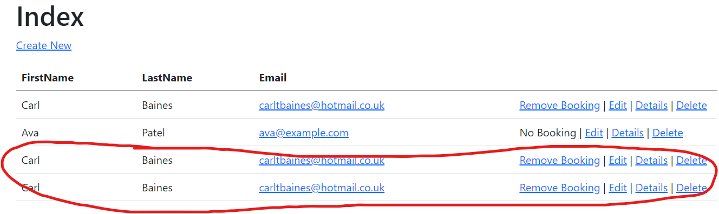 | Unintended behaviour – need to add some logic which retrieves the current list of booked guests for an Event and checks against the posted booked guest for duplicates. It also seems to have added new guests to the guests index page weirdly.
21 | List Guests for an Event including a total count of guests; | VALID | List guests for an Event and verify total count | UI: Events > Details for event with 3 guest bookings | Guest list shows 3 guests; total count displayed as 3 | 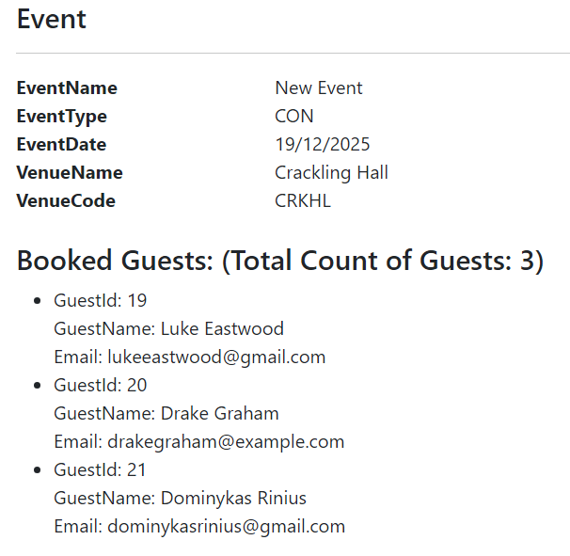 | When booking a guest onto an Event, it doesn’t actually fetch the Guests list to check whether the posted Guest actually exists. You can post a guest that is not on the guest list.
22 | List Guests for an Event including a total count of guests; | VALID | Event with zero bookings shows count correctly | UI: Events > Details for event with 0 bookings | Guest list empty/empty state; total count displayed as 0 | 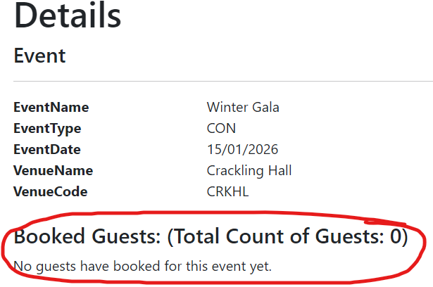 | N/A
23 | Register guest attendance for an Event; | VALID | Register attendance for a booked guest | UI: Guests > Details  Tick attendance checkbox for booked event; click Register Attendance | Attendance saved; revisit shows attending = true | 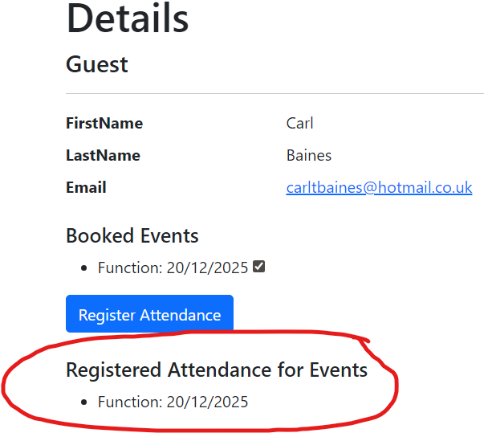 | N/A
24 | Register guest attendance for an Event; | VALID | Unregister attendance (toggle off) | UI: Guests > Details  Untick checkbox; click Register Attendance | Attendance saved; revisit shows attending = false | 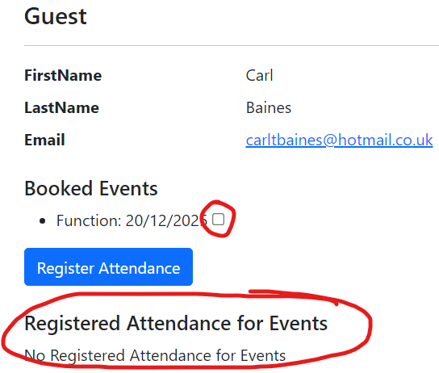 | N/A
25 | Display the details of a Guest, including information about the Events with which they are associated and their attendance; | VALID | Guest details shows associated Events + attendance | UI: Guests > Details for guest with bookings | Details lists events and attendance per event | 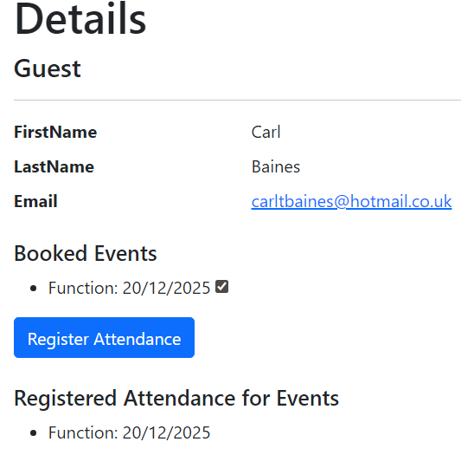 | N/A
26 | Edit an Event (except its date and type); | VALID | Edit Event (allowed fields only) | UI: Events > Edit  Change Title to Winter Gala 2 | Title updated; date/type unchanged | 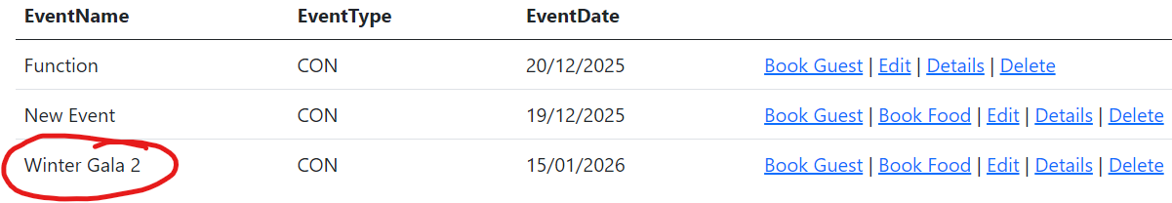 | N/A
27 | Edit an Event (except its date and type); | INVALID | Ensure date/type cannot be edited (or changes ignored) | UI: Events > Edit (date/type read-only) | Date/type unchanged; only permitted fields update | 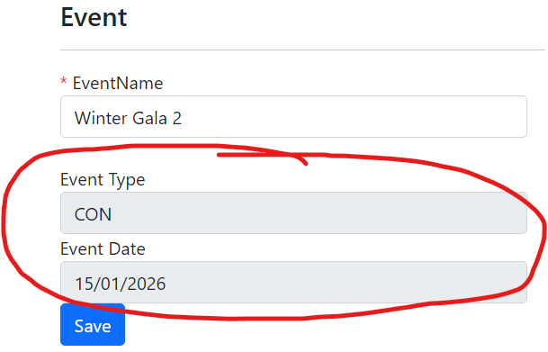 | N/A
28 | Cancel (remove) the booking of a Guest from an upcoming Event; | VALID | Cancel (remove) guest booking from upcoming Event | UI: Guests > RemoveGuestBooking  Select booking for future-dated event; confirm remove | Booking removed; guest no longer listed for event | 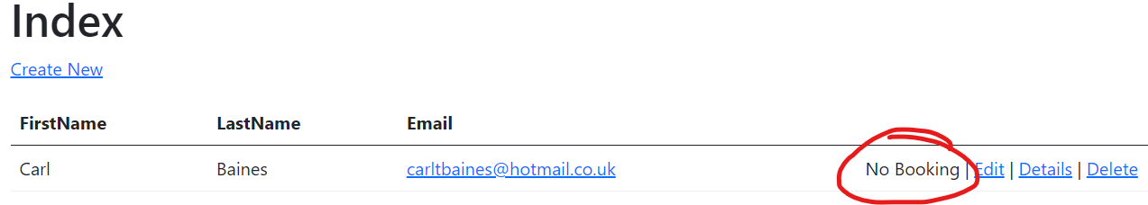  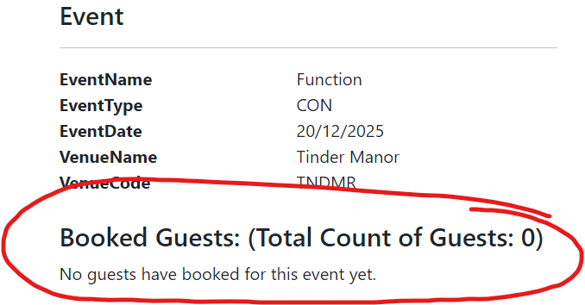 | N/A
29 | Reserve an appropriate, available Venue for an Event via the Apex.Venues web service, freeing any previously associated Venue; | PLANNED | Reserve available Venue for an Event | UI: Event Details > Reserve Venue  Select an available venue code | Venue reserved via Apex.Venues service; event shows reserved venue
30 | Reserve an appropriate, available Venue for an Event via the Apex.Venues web service, freeing any previously associated Venue; | PLANNED | Change venue reservation frees previous venue | UI: Reserve venue A then reserve venue B for same event | Event shows venue B; venue A becomes available again
31 | Display a list of Events that includes summary information about the Guests and Venue within it | PLANNED | Events list shows guest count + venue summary | UI: Events > Index | Each event row includes venue summary and guest count summary
32 | Create, list and edit Staff; | VALID | Create Staff | UI: Staffs > Create  First: Sam  Last: Taylor  Role: Team Leader | Staff created; appears in staff list | 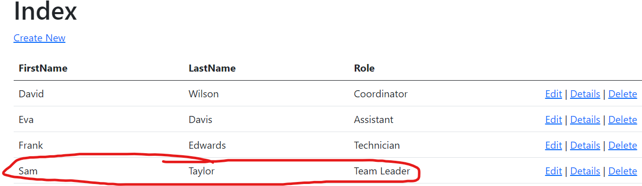 | N/A
33 | Create, list and edit Staff; | VALID | List Staff | UI: Staffs > Index | Staff list displayed | 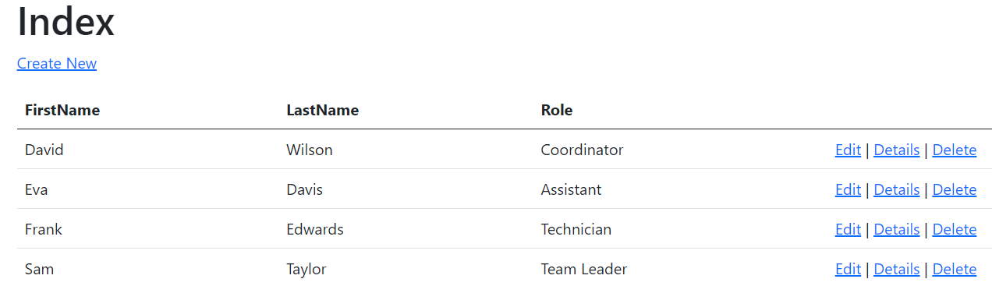 | N/A
34 | Create, list and edit Staff; | VALID | Edit Staff | UI: Staffs > Edit  Change Role to Manager | Staff updated; list/details reflect change | 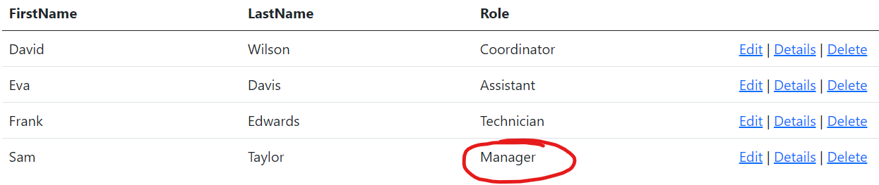 | N/A
35 | Adjust the staffing of an Event, adding available staff or removing currently assigned staff; | PLANNED | Add available Staff to an Event | UI: Staffing view  Assign staff <staffId> to event <eventId> | Assignment saved; staff shown on event
36 | Adjust the staffing of an Event, adding available staff or removing currently assigned staff; | PLANNED | Remove assigned Staff from an Event | UI: Staffing view  Remove staff <staffId> from event <eventId> | Assignment removed; staff no longer shown on event
37 | See appropriate warnings within event list and staffing views when there is not a first aider assigned to an Event; | PLANNED | Warning shown when no first aider assigned | UI: Event list/staffing view for event with no first aider | Warning displayed
38 | Display the details of a Staff member, including information about upcoming Events at which they are assigned to work; | PLANNED | Staff details show upcoming assigned events | UI: Staffs > Details for staff assigned to future events | Details lists upcoming events
39 | Cancel (soft delete) an Event, freeing any associated Venue and Staff; | PLANNED | Cancel (soft delete) Event and free Venue/Staff | UI: Cancel event with venue reserved and staff assigned | Event marked cancelled (not removed); venue freed; staff unassigned
40 | Display the details for an Event, which must include details of the Venue, Staff and Guests – this should be more detailed that the summary information found in the Event list; | PLANNED | Event Details includes Venue, Staff and Guests (more detail than list) | UI: Events > Details for event with venue/staff/guests | Details shows venue + staff + guests and is more detailed than Index summary
41 | Permanently remove personal data by anonymising their Guest entity; | PLANNED | Anonymise Guest personal data | UI: Guest > Anonymise action | Personal data removed/overwritten; guest entity remains for history
42 | Display a detailed list of available Venues, filtered by EventType and date range, and then create a new Event by picking a result; | PLANNED | Filter venue list by type/date range and create Event from selection | UI: Venue search  Type: Conference  Range: 2026-02-01 to 2026-02-07  Pick venue and create event | Filtered venues shown; event created using selected venue
43 | See appropriate warnings within event list and staffing views when there are fewer than one member of staff per 10 guests assigned to an Event. | PLANNED | Staffing ratio warning triggers (1 staff per 10 guests) | UI: Event with 50 guests and 4 staff assigned | Warning displayed (insufficient staffing)
44 | User access control should restrict (see assignment for details) | PLANNED | Manager can create/edit staff (authorised) | Login as Manager; attempt Staff Create/Edit | Access granted; changes saved
45 | User access control should restrict (see assignment for details) | PLANNED | Non-manager cannot create/edit staff (unauthorised) | Login as non-manager; attempt Staff Create/Edit | Access denied; no changes saved
46 | User access control should restrict (see assignment for details) | PLANNED | Team Leader/Manager can adjust staffing (authorised) | Login as Team Leader/Manager; adjust event staffing | Access granted; staffing updated
47 | User access control should restrict (see assignment for details) | PLANNED | Regular user cannot adjust staffing (unauthorised) | Login as regular user; attempt to adjust staffing | Access denied; no changes saved
48 | User access control should restrict (see assignment for details) | PLANNED | Team Leader/Manager can permanently delete (authorised) | Login as Team Leader/Manager; perform permanent delete | Access granted; record deleted
49 | User access control should restrict (see assignment for details) | PLANNED | Regular user cannot permanently delete (unauthorised) | Login as regular user; attempt permanent delete | Access denied; record remains

